

BagiKopi Cafe Management

Group 3

Names : Dafa Radhitya Hanif

Class : 2ISA1

CEP CCIT

# FAKULTAS TEKNIK UNIVERSITAS INDONESIA

2024

**PROJECT ON**

*Clinic Management*

**Developed by**

1. **Dafa Radhitya Hanif**
2. **N**
3. **D**

# **BagiKopi Cafe Management**

|  |
| --- |
| Batch Code : 2ISA1  Start Date : 20 February 2025  End Date : 06 March 2025  Name of Faculty : Mr. Harry Prasetyo Rosianto, S.Tr,T.  Names of Developer :   1. Dafa Radhitya Hanif 2. D 3. C   Date of Submission: 06 March 2025 |

# **CERTIFICATE**

This is to certify that this report titled “BagiKopi Cafe Management” embodies the original work done by Dafa Radhitya Hanif and D and D. Project in partial fulfillment of their course requirement at CEP-CCIT FTUI.

Coordinator:

Mr. Harry Prasetyo Rosianto, S.Tr,T.

## ACKNOWLEDGEMENT

Praise be expressed to the presence of Allah SWT. who gave us all the strength, patience, and

courage to be able to complete this report. Not forgetting let us to laud the prayers and greetings

to the Great Prophet Muhammad saw. who has been our role model throughout the ages. We

are also thankful to our parents and faculty who supported us for completing this report.

As a part of the CEP CCIT FTUI and in order to gain knowledge about Management, we are

required to make a report about “Clinic Management”. The basic objective behind doing this

project is to get knowledge about Management in a Clinic.

The compilers realize that there may be numerous errors and deficiencies in this paper, therefore the authors really expect constructive suggestions from the readers, to enhance the paper's quality. The authors hope that this paper, in addition to fulfilling the requirements, can also enrich readers' understanding. Finally, the authors hope that the kindness and assistance

given to the compilers will be rewarded by Allah SWT.

## BACKGROUND

|  |
| --- |
| In today's fast-paced world, managing a clinic efficiently is essential to provide top-notch patient care and keep administrative tasks running smoothly. A good clinic management system helps handle appointments, patient records, billing, inventory, and more. Python is a great choice for developing such a system because it's flexible, easy to use, and has lots of helpful libraries.  The main goal of this project is to create a user-friendly, scalable, and secure Clinic Management System (CMS) that automates and simplifies daily clinic operations while keeping patient data private and safe.  **Key Features**     1. **Login Validation**: Ensures secure login with validation for username and password 2. **Patient Management**: Provides functionality to update patient information and search for patients by name and displays all patient data in a readable format. 3. **Doctor Management**: Automatically assigns a doctor based on the patient's complaint. 4. **Transaction Management**: Creates and manages transaction records, linking patients to their respective doctors based on complaints and displays all transaction data in a readable format. 5. **Complaint-Specific Doctor Assignment**: Matches patients to doctors based on the nature of their complaints (e.g., dental, respiratory, eye, pediatric, and obstetric complaints). 6. **Main Menu Interface**: Provides an interactive main menu with options for patient registration, displaying all patient data, searching for patients by name, updating patient data, displaying transaction details, and exiting the program. 7. **Auto-Incrementing Patient IDs**: Automatically generates a unique patient ID for each new patient added to the system. |

**SYSTEM ANALYSIS**

The clinic management system is crafted to automate and streamline clinic operations by

ensuring secure access and efficient handling of patients, doctors, and transactions. It consists

of several key components, including login validation to enforce secure access through specific

username and password requirements. Patient management is a critical part of the system, allowing for patient registration, updates to patient information, and the ability to search for patients by name. Doctor management maintains detailed information about each doctor and assigns doctors to patients based on their complaints. Transaction management tracks and links

these patient-doctor interactions.

The main menu interface is designed to be user-friendly, offering easy navigation options like patient registration, data display, searching for patients, updating patient information, and

displaying transaction details. This intuitive interface simplifies the tasks involved in managing clinic operations. The system's strengths lie in its user-friendly design, secure login validation, ssssscomprehensive management of clinic operations, and its scalable, modular structure that can adapt to future needs.

Despite these strengths, there are areas for improvement. Enhancing error handling would help manage unexpected inputs, while integrating a database would provide persistent data storage.

Improving the user interface for better interaction and implementing logging to track user

actions and system events would further enhance the system's reliability and user experience.

Addressing these areas would make the clinic management system more robust and reliable, providing a seamless experience for users and ensuring efficient clinic operations. The system has a strong foundation with the potential to evolve into a comprehensive tool for clinic management, ultimately improving the quality of patient care and streamlining administrative

processes.

# **FLOWCHART**

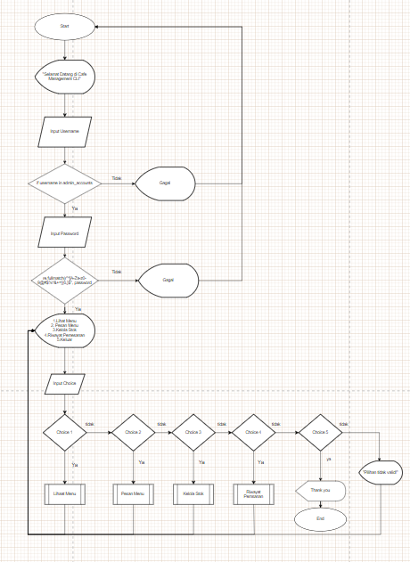

|  |
| --- |
|  |

|  |
| --- |
|  |

|  |
| --- |
|  |

|  |
| --- |
|  |

|  |
| --- |
|  |

**SOURCE CODE**

|  |
| --- |
|  |

\

sssssssssss

5.

If in the main menu we select option 2, which is “

Tampilkan Semua Data Pasien

"

or it means

Display all patient data

, the program will show all registered patient data. After that, we will

return to the main menu.

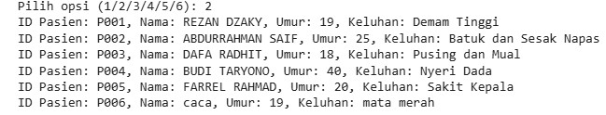

6.

If in the main menu we select option 3, which is

“Cari Pasien Berdasarkan Nama

"

or it means

Search for patients by name

, we will first enter the name of the patient we want to search for,

then the program will display th

e search results. After that, we will return to the main menu.

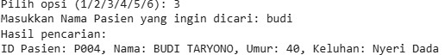

7.

If in the main menu we select option 4, which is

“Update Data Pasien

"

or it means

Update

patient data

, we will first enter the patient's ID whose data we

want to change, then the program

will input the new data such as name, age, and complaint. After that, we will return to the main

menu.

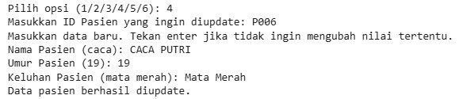

\

sssssssssss

8.

If

in the main menu

we select option 5, which is "

Tampilkan Detail T

ransaksi

"

or it means

Display transaction details, the program will show transactions that were previously made for

patient registration. After that, we will return to the main menu.

9.

If in the main menu we

select option 6, which is “Keluar" or it means Exit, the program will

finish.



**CONFIGURATION**

|  |  |  |  |  |  |  |  |  |  |  |  |  |  |  |  |
| --- | --- | --- | --- | --- | --- | --- | --- | --- | --- | --- | --- | --- | --- | --- | --- |
| **Hardware :** Laptop      **Operating System :** Windows 11      **Software :** Microsoft Word  2019 Microsoft  Power Point 2019  Colab research and draw.io on Chrome Browser           |  |  |  | | --- | --- | --- | |  | **PROJECT FILE DETAILS** | | | **No** | **File Name** | **Remarks** | | 1. | Group 9_Clinic Management.docx | Microsoft Word that contains report | | 2. | Group 9_Clinic Management.pdf | PDF that contains report | | 3. | Group 9_Clinic Management.pptx | Microsoft Power Point that contains presentation slide | |